Participant Name:  Registration No:  Course:  Course year:  Institution/research centre Name:  Email Address:  Guide/Corresponding Author Name and affiliation:  Co-guide/s name and affiliation:  Stream: (please tick)  - Health Sciences (HS)  - Science and Technology (ST)  - Humanities, Liberal arts, Social Science and Management (HLSM)  No. of Publications:  No. of Conference Presentations:  Any Other Achievements: | Research Title: Times New Roman, 11 point, bold, sentence case.  Background: Times New Roman, 11-point, sentence case; Maximum 50 words  Objectives: Times New Roman, 11-point, sentence case; Maximum 30 words  Methodology: Times New Roman, 11-point, sentence case; Maximum 100 words  Results: Times New Roman, 11-point, sentence case; Maximum 100 words.  Conclusion drawn from results: Times New Roman, 12-point, sentence case; Maximum 70 words  Keywords: Maximum 5

*Remove all the instructions highlighted in RED before submission

SIMILARITY INDEX
(The first page of your Turnitin report should look something like this. Your guide must sign on this page, and a scanned copy must be uploaded in the portal)
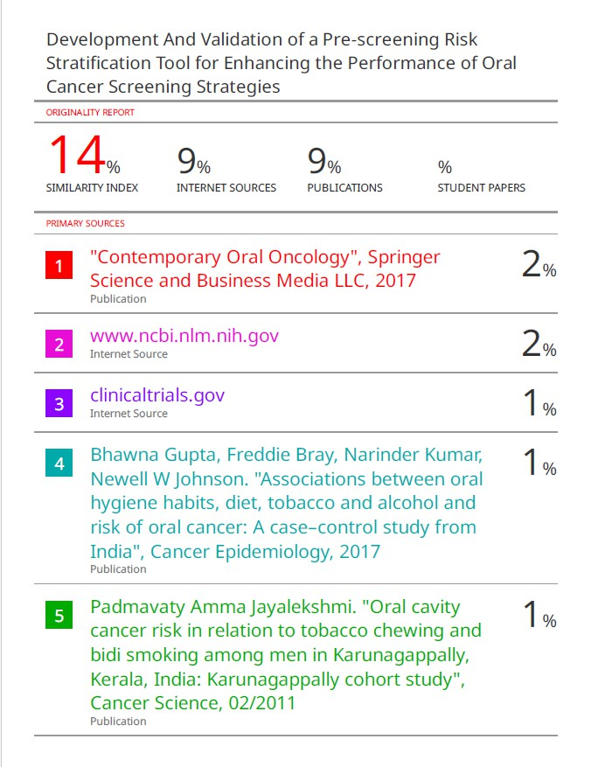

TITLE OF YOUR ABSTRACT

GUIDE/CORRESPONDING AUTHOR’S SIGNATURE: _______________________

